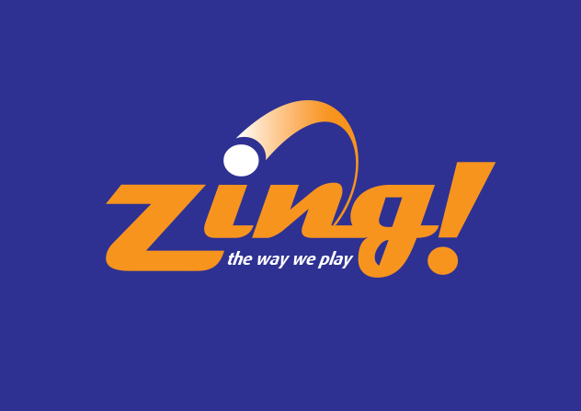 | Zing! Table Tennis Center  USATT Sanctioned Tournament  Saturday, October 21, 2017

Event: Round Robin groups with top two players advancing to Single Elimination playoffs.

Event # | Event Name | Format | Start Time | Fee | 1st | 2nd | Limit
1 | Open | RR/SE* | 3:00 PM | $30 | $180 | $100 | 16
2 | Under 2000 | RR/SE* | 12:30 PM | $25 | $80 | $40 | 16
3 | Under 1600 | RR/SE* | 10:30 AM | $20 | Trophy | Medal | 16
4 | Under 1300 | RR/SE* | 12:30 PM | $20 | Trophy | Medal | 16
5 | Under 1000 | RR/SE* | 10:30 AM | $20 | Trophy | Medal | 16

* RR = Round Robin; SE = Single Elimination

- Format:
  - Round Robin groups with top two from each group advancing to Single Elimination playoffs.
  - 3-5 players will be assigned to each Round Robin group.

- Facilities and Equipment:
  - Nine tables - eight Donic ITTF approved tables plus one Donic Galaxy table.
  - 15’ high ceilings and all LED lighting with 28’ x 12’ courts. Wood flooring.
  - Xu Shaofa 3-star 40+mm poly balls (white) ITTF-approved will be used.

- Rules:
  - All games are played to 11 points. All matches are best 3 of 5 games.
  - This is a USATT “0-Star” Tournament. USATT rules will apply.
  - All players require an active USATT membership or a USATT one-day tournament pass.
  - USATT dress code is enforced. No white clothing. Clean sneakers required.
  - Players must arrive at match table within 5 minutes of start time or default that match.
  - The latest USATT rating file posted prior to 10/15/2017 will be used for player qualification.
  - Rated players cannot play an event below their USATT rating.
  - Unrated players may enter any event.
  - Unrated players may not advance from a RR group into the SE stage unless they've been assigned an estimated rating by a tournament official, but can’t advance in any event below their estimated rating.
  - Players can’t compete in two events starting at the same time.
  - Trophies and medals must be picked up within two weeks of tournament date.
  - The decisions of tournament officials are final.

- Tournament Officials:
  - Tournament Director: Noel Abbott.
  - Tournament Committee – Larry Bavly, Steve Kasha, Noel Abbott (serve as Referee).

- Lunch, snacks, and drinks present on site. Email ahead for lunch selections.
- Doors open at 9:45 AM. Check in at least 15 minutes before your first scheduled event.
- Tournament Software: Sportfist.

- Cancellation Policy:
  - Players will be refunded entry fees on week prior to tournament date less a $5- administrative fee.
  - Refunds will not be given after that date. No refunds for no-show participants.

Zing! Table Tennis Center October 21st 2017 Tournament Entry Form

First Name Last Name

USATT Member ID/Expiry Date / USATT Rating:

New USATT Member?
Email Address: (Please type or print clearly). |  | Date of Birth (MM/DD/YY)
Street Address | City | State & Zip:
Mobile Phone: | Home or Office Phone:
Home Club:
Names of other entrants you play with:

Circle the event(s) you wish to enter:  1 2 3 4 5  Total Event Fee(s): $_______  Official Fee: $___3___  USATT Membership Fee $_______  Under 18: $45; 18 and older: $75  Tournament Day Fee: $20  Three-year membership: $210  TOTAL AMOUNT DUE: $________ | By my participation, I hereby release Table Tennis Express LLC dba Zing! Table Tennis Center, USATT and tournament committee of any liabilities for injury to myself and/or property damage or loss. I agree to comply with all decisions of the tournament officials. I will abide by all USATT/ITTF regulations.  Signature (Parent or Guardian if minor):  Date:____/____/2017

Registration Process:
- Complete, sign, and return Tournament Entry Form by email to Noel@ZingTT.com, by mail with check (address below), or drop off at Zing!
- Make full payment.

Submission Deadlines:
- By mail: Must be postmarked by Sat, Oct. 14th.
- Online or in Person: Friday, Oct. 20th by 2 PM.

Payment:
Make payment by check, Paypal, or cash:
  - By Check: Make payable to Table Tennis Express LLC and mail to Zing! Table Tennis Center
122 Pleasant Street, Suite 111 Easthampton, MA 01027. Deadline for mailing: Sat, Oct 14th.
  - By PayPal: Use the link www.paypal.me/ZingTT Add $2 credit card fee.
  - By Cash: Drop off at Zing!. Receipt provided.

For more information contact Noel Abbott, Zing! Table Tennis Center at Noel@ZingTT.com
or (413) 203-5942.

Zing Table Tennis Center 122 Pleasant Street, Suite 111 Easthampton, MA
(413) 203-5942 • ZingTT.com • Noel@ZingTT.com

